Hi [NAME]
Welcome to your new Neo1 platform!

As a Neo1 user, you will gain access to an enhanced booking experience and benefits, designed to make planning your travel more enjoyable and stress-free.

To get started, you will receive an email to set your password on Neo1 (see example below). Your username is your email address.

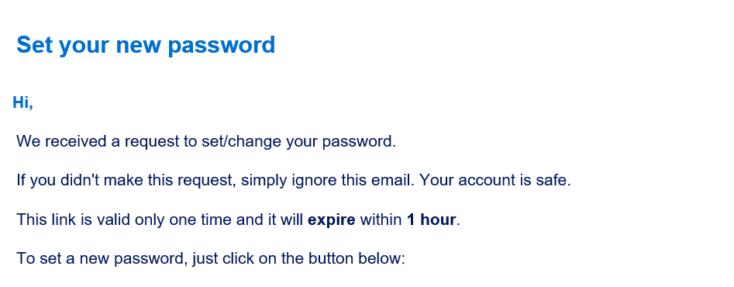

Once you have successfully logged in, please complete your travel profile by clicking your initials in the upper left corner of Neo1, click on the guide below for assistance:

- Guide – Complete your travel profile
Once your profile is updated, you are ready to move forward with using Neo1 for travel. See the below guides to aid you in your use of the platform.
Travel support guides:
- How to book a flight, hotel, car, train
- How to modify or cancel a trip
- Access travel invoices
Mobile app:
- Amex GBT mobile app - Managing travel (allow 24 hours for travel profile updates to sync to app)

Help with all travel related inquiries & booking: +1 669-272-1301 and press Option 2 (24/7 support line) or, add this number to WhatsApp - +1 (646) 553-1753

Please contact your Neo1 company administrator for any platform set up assistance or email our Customer Success team at help@neo1.com.

Thank you

[ADMINISTRATOR NAME]

