Neo1
Release notes
March 2024

Table of Contents
Enhancements 2

Company settings layout update 2

Company Settings: Accouting changes to Fields 3

Improve the virtual Card budget request flow 4
Other updates: 7

Improvements 7

Fixes 7

Enhancements

Company settings layout update
Impact: All Admins for UK & US businesses
- New icon for settings has been added on the top right of the Neo1 app
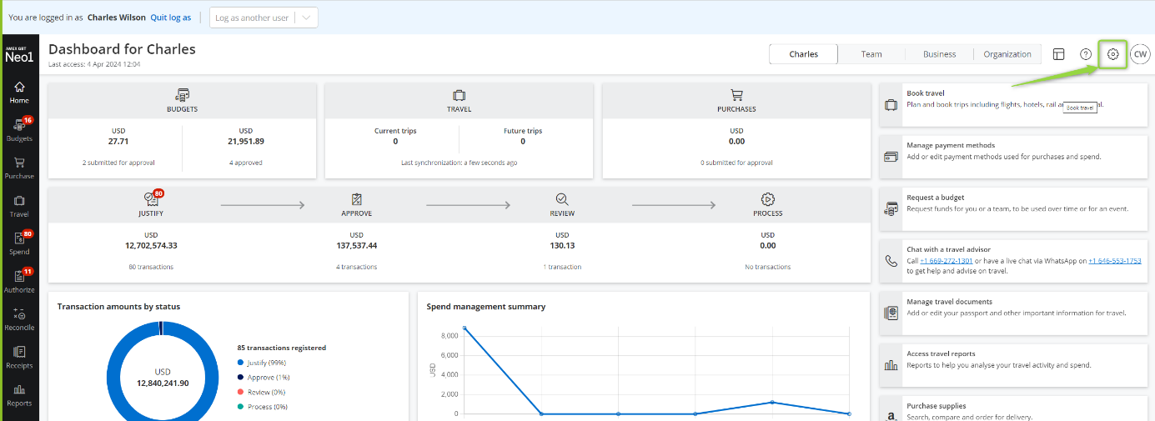
- New grouping for the Business Settings tab: General and Expense
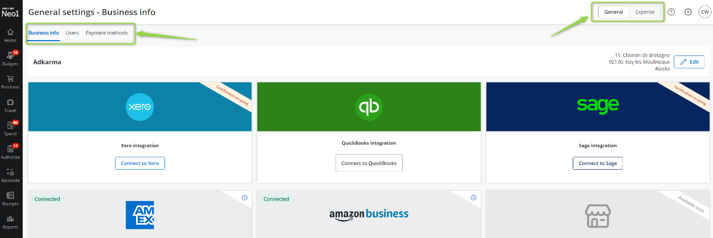
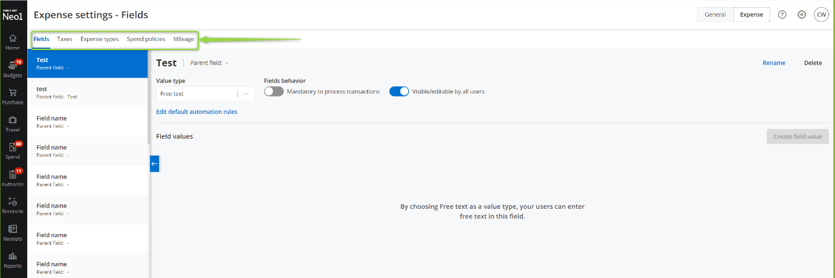

Company Settings: Accouting changes to Fields
Impact: All Admins for UK & US businesses
- Accounting segments renamed to Fields and Field values
- New Filed layout for better usability
- New Edit automation rules screen that will help the admins
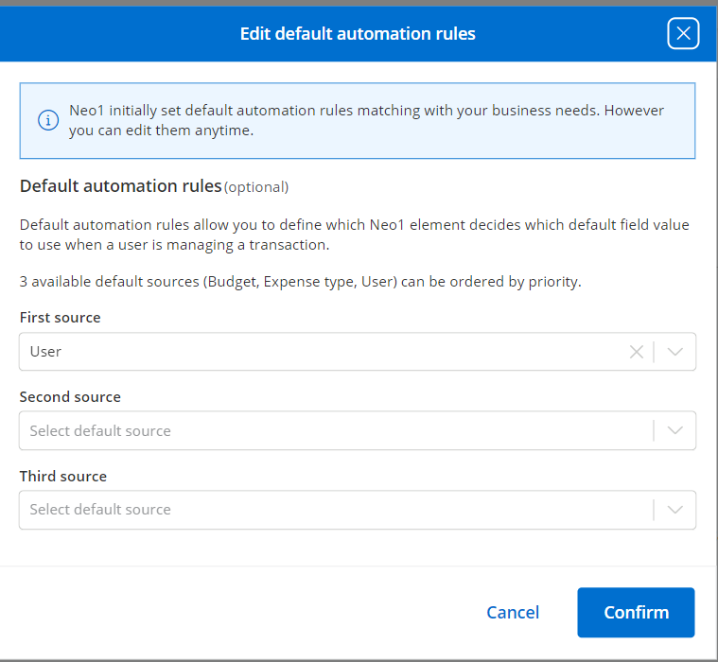
- New Parent-Child relationship displayed on the Fields
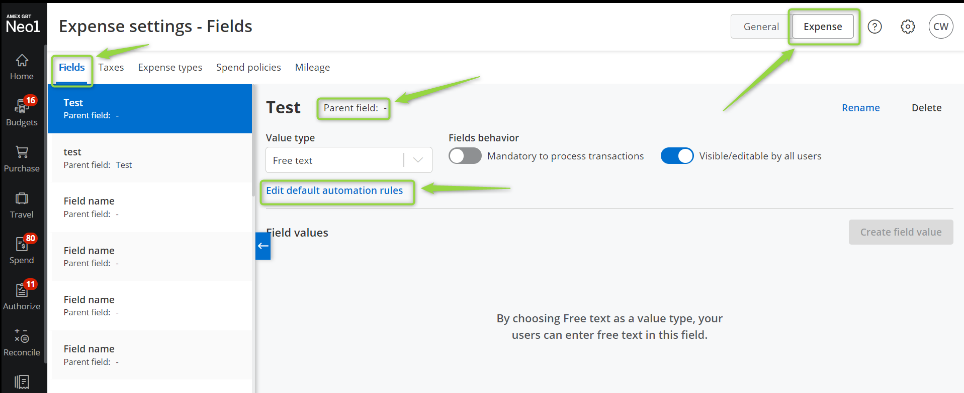

Improve the virtual Card budget request flow
Impact: All users for US businesses connected to Neo1 virtual Card service
- When asking for a new budget to fund the card, the user must answer a simple question and that will open the budget creation screen with the virtual Card funding toggle active
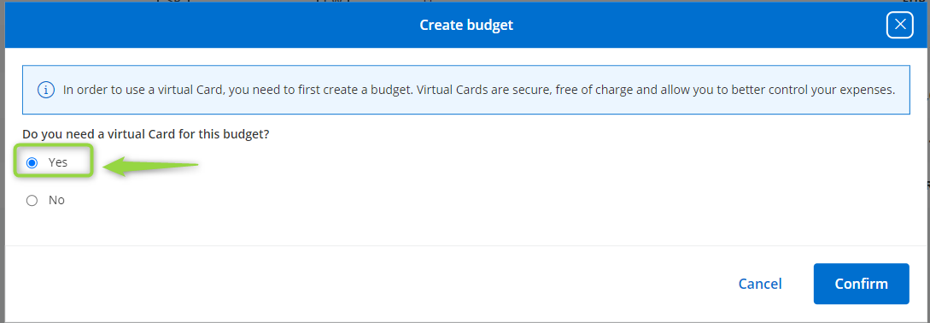
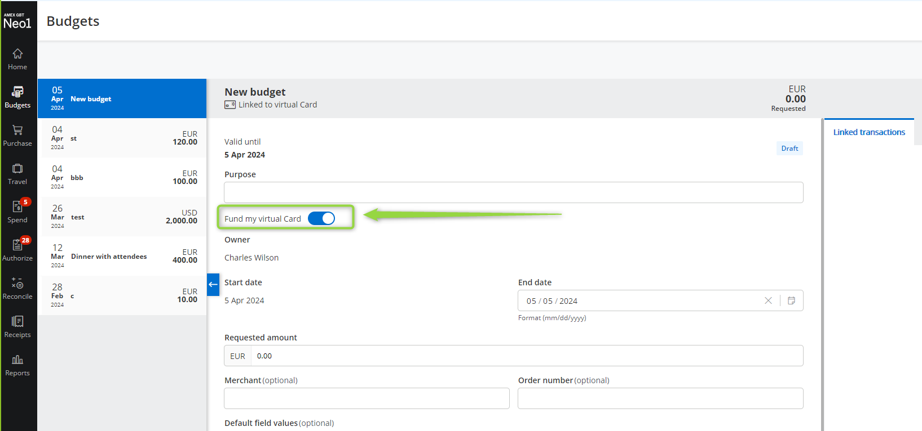
- If a virtual Card funding budget is already available and active, pressing answering “yes” to the question will open the existing budget and will let the budget owner request a change
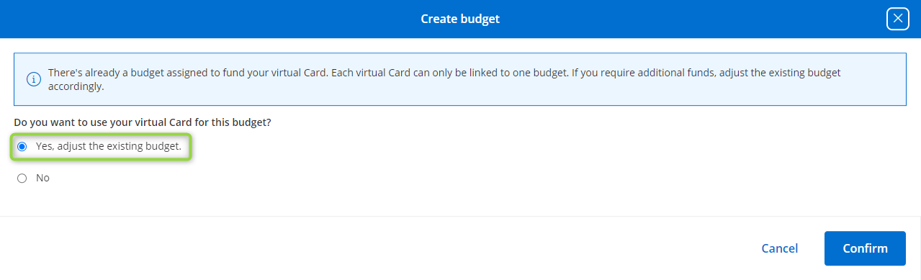
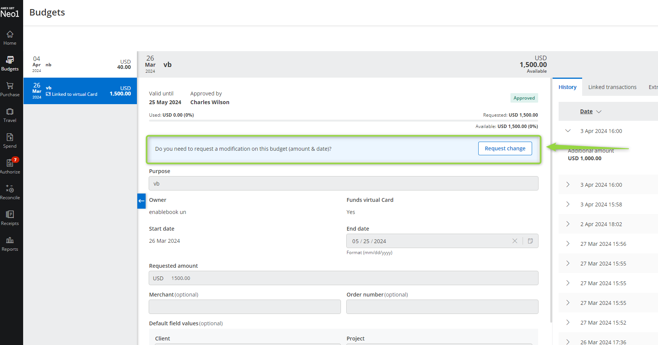
Other updates:

Improvements
- Display travel receipts for UK businesses
- Allow admins and finance users to delete imported bank (GL1025) transactions for US and UK businesses
- Allow admins and finance users to delete virtual transactions for US businesses

Fixes
Version | Ticket number | Description | Impact
24.03.10 |  | Stabilization tickets | All US and UK businesses

